**AUTOMATED WATER TANK MONITORING**

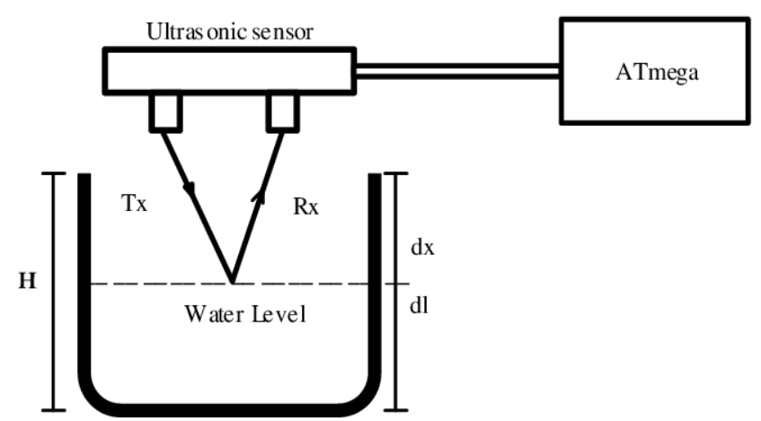

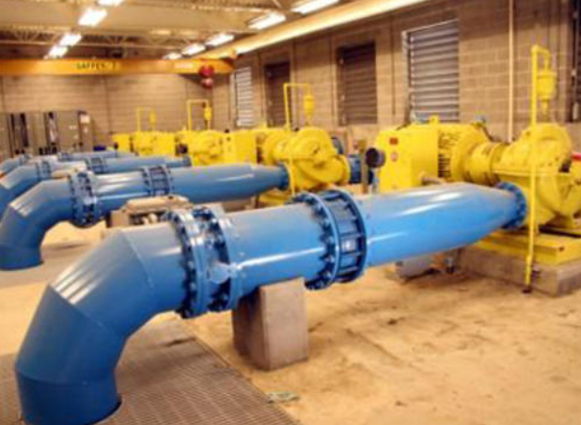

RASPBERRY PI

**SMART BIN – GARBAGE BIN MONITORING SYSTEM**

**EMAIL**

**SMS**

**WHATSAPP**

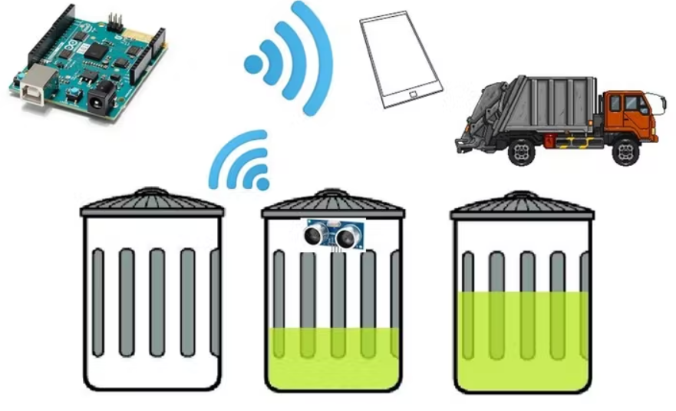

**ROBOTICS – OBSTACLE AVOIDANCE**

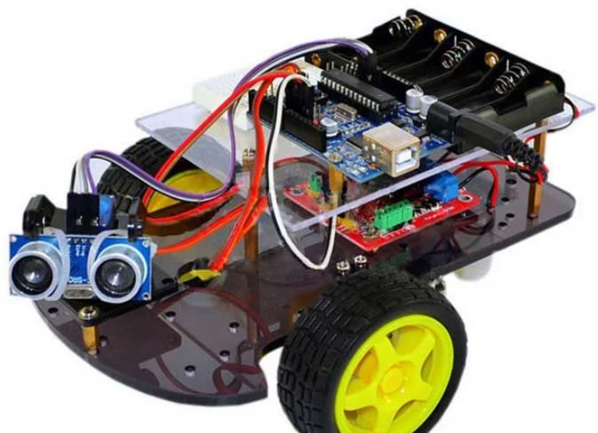

**RADAR APPLICATION**

